JACOB LAWRENCE 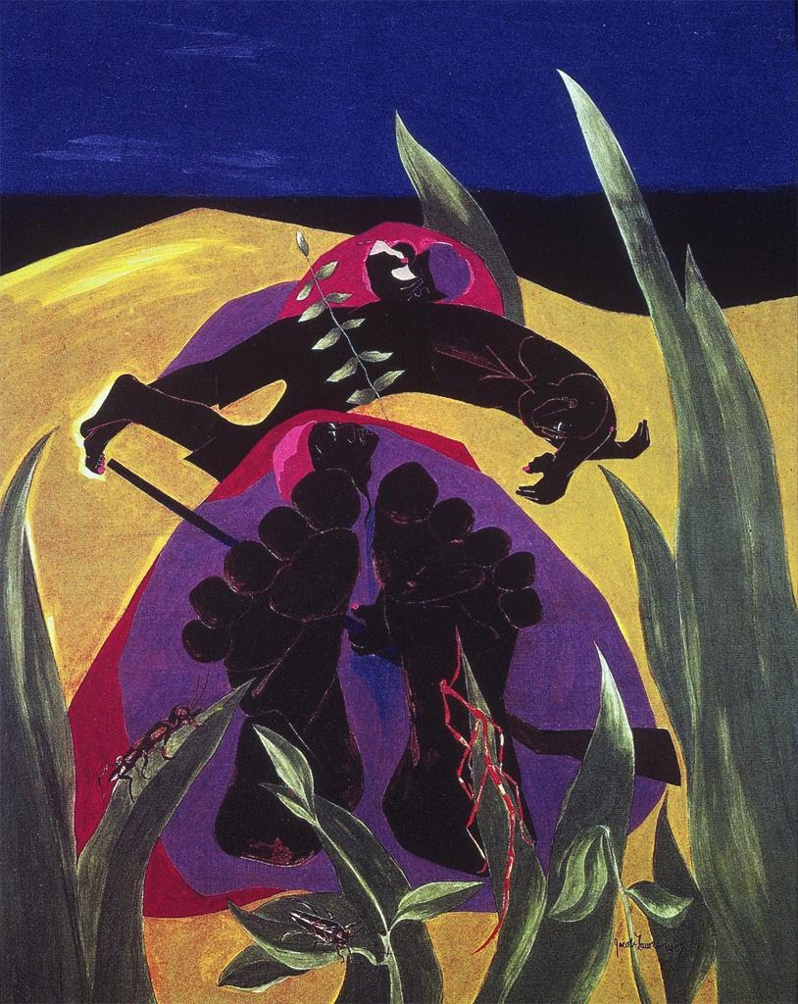
Daybreak—A Time to Rest is one in a series of panel paintings that tell the story of Harriet Tubman (c. 1820–1913), the famed African-American woman who freed slaves using a fragile network of safe houses called the Underground Railroad. This abstracted image emphasizes Tubman's bravery in the face of constant danger. Lying on the hard ground beside a couple and their baby, she holds a rifle. Her face, pointing upward to the sky, occupies the near center of the canvas, her "body" surrounded by purple. Tubman's enormous feet, grossly out of proportion, become the focal point of the work. The lines delineating her toes and muscles look like carvings in a rock, as if to emphasize the arduous journeys she has made. Reeds in the foreground frame the prone runaways. Three insects (walking stick, beetle, and ant) are signs of activity at daybreak.
Jacob Lawrence is renowned for his narrative painting series that chronicles the experiences of African-Americans, which he created during a career of more than six decades. Using geometric shapes and bold colors on flattened picture planes to express his emotions, he fleshed out the lives of Tubman, Frederick Douglass, John Brown, and African-Americans migrating north from the rural south during and after slavery. Lawrence was twelve in 1929 when his family settled in Harlem, New York, at a time when African-American intellectual and artistic life was flourishing there. As a teen, he took classes at the Harlem Art Workshop and Harlem Community Art Center, where he studied works of art by African-American artists and learned about African art and history. Lawrence went on to create images that are major expressions of the history and experience of African-Americans.

