RFL VISUAL ART
SPRING BREAK PACKET

Your spring break homework is to explore color theory by creating a color wheel using found objects. This assignment is worth 100 points and will be your first grade of 4th quarter. A color wheel is a circle with sections used to show the relationship between colors. At its most basic the color wheel has the three primary colors (red, blue, and yellow) and the three main secondary colors (violet, green and orange). Although we can use color without understanding color theory, understanding the relationships between colors is important to many art and design applications.
Below is a basic color wheel:
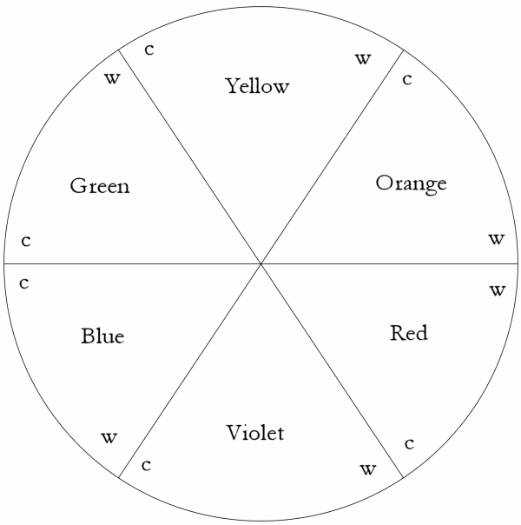

Your homework is to use found objects such as plants, toys, trash, and other found objects to create a color wheel that includes: red, orange, yellow, green, blue and violet (purple).
The best way for you to turn in your spring break homework is to take a photo of your found object color wheel and upload it to Instagram and tag me: ms.simsvisualart. Alternatively you may text or email me: HKSims@bcps.k12.md.us. If you would prefer, you may glue your found objects down and bring your color wheel to school after spring break.
For more information and visuals visit our class website: http://hksims.weebly.com/quarter-4.html
You also have the optional assignment of creating an acrylic gel transfer print. An attempt at creating an acrylic gel transfer print over the break will earn you 100 extra credit points going into the 4th quarter.
Have a wonderful break and be safe!

